# Homework 1 - Networking Utilities

Jackson Mundy

## Task 1

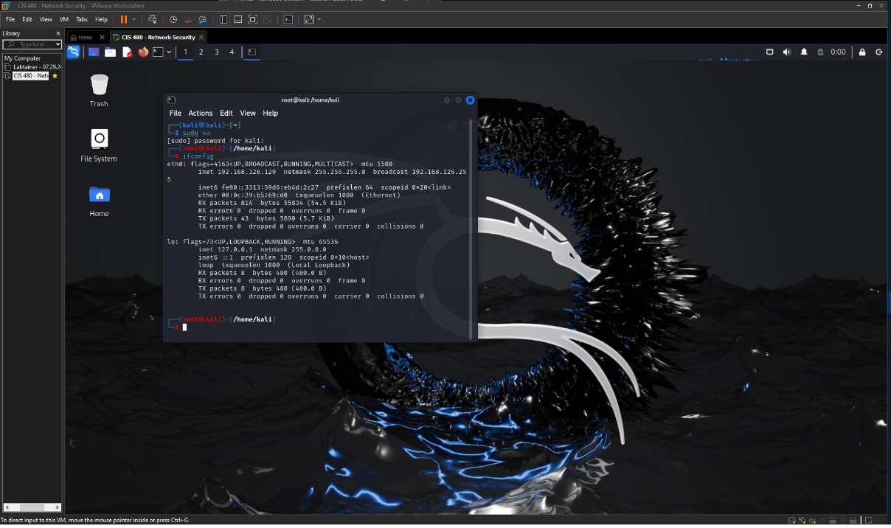

## Task 2

## Task 3

## Task 4

## Task 5

## Task 6

